Converting a string type into a byte type

We can convert a string type into a byte type by using the encode() function.

For example.

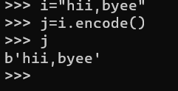

**Converting a byte object to a string object**

To convert a byte object to a string object, we use the decode() function

For example:

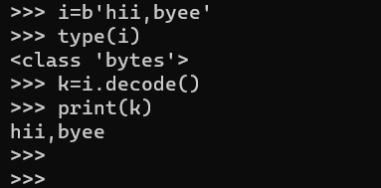

To check the length of the byte object

To check the length of the byte object, we have to use the len() function. It counts the commas inside the byte values also.

For example:

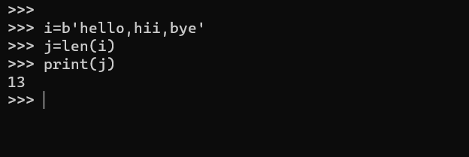

**To concatenate two bytes:**

To concatenate two bytes we have to use the ‘+’ operator.

For example:

